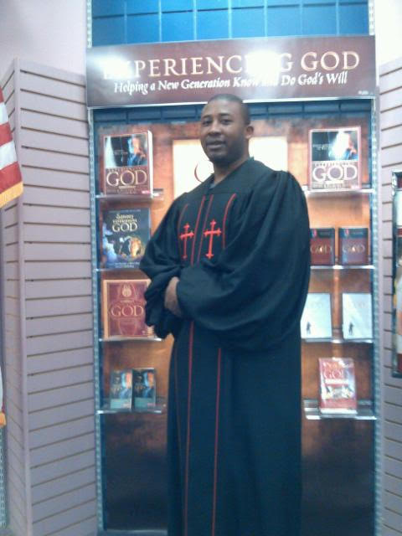Anthony M. Utsey
1900 Taylor Street • Hollywood, FL 33020 (803) 387.4450 • anthonyutsey803@yahoo.com

PERSONAL INFORMATION:
Birth date: October 1, 1979
Hometown: Orangeburg, SC
Single Status
Licensed and Ordained: April 6, 1997- True Vine Christian Church, Orangeburg, SC
Interests: History, Community Involvement, Reading, Sports and Volunteering Services

MINISTRY OBJECTIVE:
To lead the people of God to a greater knowledge of a deeper relationship with the Lord by feeding them the unadulterated Word of God and shepherding their hearts, to better equip the saints to accomplish His will and purposes, and to share with the unsaved as to how to find real life and true freedom in Christ.

PASTORAL LEADERSHIP & ORGANIZATIONAL PLANNING:
Personable, self-motivated, visionary, and goal-oriented professional with hands-on experiences as well as scholastic training in Pastoral ministry, organizational leadership and development, interpersonal communication, and event coordination. Pleasant, teachable worker with compassion towards the people of God. Effective team player who is devoted to collective and personal goals of ministry. Seeking a challenging full-time career opportunity in Pastoral Ministry, organizational planning, and leadership development.

EDUCATION:
Emmaus Bible College: Dubuque, IA; Major: Bachelor of Science in Biblical and Christian Studies Graduate: ‘04

High School Diploma: Orangeburg Wilkinson, Orangeburg, SC ‘98; Major: Air force JROTC GPA: 3.0

MINISTERIAL EXPERIENCE/EMPLOYMENT:
Preacher/Teacher/Evangelism Leader: Grace Fellowship Bible Church, Valdosta, GA 2007-2009
Preach the entire counsel of the Bible (Luke 4:18; Mark 16:15). Teach God’s principles and practices in faithfulness and sound doctrine (Ephesians 4:1-7). Instruct in methods of implementation and practical applications of the teachings of scripture (Phil. 4:8; 2 Timothy 3:16-17).

Pastor & Leadership Development Coach: Divine Mind Prayer Temple, Orangeburg, SC 2000-2006
Facilitate successful planning and execution of all events at a 500+ member Congregation. Oversee success of Church involvement with various national organizations. Coordinate and moderate planning meetings with Ministry Leaders, Media Team, and Volunteer workers. Assist in coordination of intake ministry and orientation/support programs for new leaders/members.

Co-Founder/Associate Pastor/ Teacher: Shepard House, Orangeburg, SC 2000-2005
Implement the success of local church ministry from the inception to over a 1000+member Congregation. Establish Evangelism Crusades to ensure community involvement. Teach and exemplify curriculum that promotes Church Leadership and Development within the Church and local Community. Preach Teach and Instruct in sound doctrine to build the lives of God’s people.

Minister/Youth Director: True Vine Christian Church: Orangeburg, SC, 1996-2000
Establish Youth & Young Adults in various youth and young adult initiatives. Organize and develop two different youth programs between ages 8-12, ages 13-18 and young adults between ages 19-25. Ensure proper dispensation of correspondence between approximately ninety families and the prospective ministerial programs. Mentor the youth in social, spiritual, and financial development. Serve in the area of Pastoral Care and Empowerment.

Anthony M. Utsey’s, Page 2
SECULAR EXPERIENCE/EMPLOYMENT:
Employment Specialist: Circle of Life Incorporated, Charlotte, NC, 2011-Present
Develop comprehensive employment strategies that assist mental, emotional and behaviorally challenged clients to secure a full/part-time career. Technology skills, job training, and technical skills. Provide a detail report analysis on all clients on a weekly basis. Communicating with individuals on the job site and in the community, providing life’s options where hope has been deferred.

LEADERSHIP/TRAINING EXPERIENCE:
Doctrinal Education & Evangelism Training: Grace Fellowship Bible Church, Valdosta, GA, 2007-2008
Presided as leader of the evangelism crusades that provides training and equips leaders as to how to properly share the gospel of Jesus Christ to the community and the world through discipleship.

Pastoral Care Training: Divine Mind Prayer Temple, Orangeburg, SC, 2000-2001
Received refresher course in pastoral care.

Church & Leadership Education: Shepherd House, Orangeburg, SC, 1999-2000
Developed and distributed constructive study materials that reinforced Christian leadership training, Pastoral care training, Doctrinal education, and the preaching/teaching of the Gospel message.

Christian & Youth Development Training: True Vine Christian Church, Orangeburg, SC, 1996-1997
Developed, Organized and Established the Youth and Youth Adult Initiatives that aided in the growth of the entire congregation.

TECHNOLOGICAL PROFICIENCIES:
Windows • Internet/Email • Network Installation/System Administration • Microsoft Office Suite
(Word, PowerPoint, Excel, Publisher, Typing, & Outlook, Access, etc.)

PERSONAL STATEMENT OF SALVATION AND CALL TO MINISTRY:
I was raised in a Christian household. My great grandmother ensured that I was acquainted with the teachings of Christ and the church during my childhood. Subsequently, I accepted Jesus Christ as my Lord and Savior at an early age. I was highly active in church from that point forward. At the age of 14, I diligently began to seek the knowledge of Christ through personal relationship and His word. On my 16th birthday, I accepted what I considered a divine calling to the Pastoral, Preaching, and Teaching Gospel ministry. This is where I started on a proactive path towards Christian leadership training, Pastoral care training, Doctrinal education, and the preaching of the Gospel message. I have been steadfast in the faith ever since this start. Under the supervision and charge of wonderful wise counselors, elders, and Pastors. I have grown tremendously in the faith and practices. Subsequently, my hope is built on nothing less than Jesus Christ Blood and His righteousness.

MINISTRY STATEMENT:
As believers, we are all called to always be ready to give a reason as to the hope that we have. (1 Peter 3:15) Thus, as one called to specific office in the body, the charge to equip the saints is of utmost importance. (Eph. 4:12-13) The overarching goal of ministry is found in (2 Corinthians 5:18-20). God desires that people live lives indicative of his presence, leadership, and an unequivocal faith in Him. Effective ministry develops mature Christians able to withstand, endure, triumph, and ultimately represent the embodiment of God’s will for humanity. Apart from the Word of God, this is impossible. Therefore, study and practice of the sacred scriptures is necessary for proper nourishment and growth. (2 Tim. 2:15) It is after such steadfastness that we are able to truly appreciate the byproduct of God’s great grace toward us. (Colossians 2:6-7)

DOCTRINAL BELIEF: (John 1:1)
I believe in God the Father, who, in His sovereignty rules over all. I believe in Jesus the Son (death, buried, resurrected, and ascended), who came to offer eternal life to those who repent, believe, and faithfully obey him. I believe in the active presence of the Holy Spirit, who effectively works in the lives of believers. I believe the KJV Bible to be the infallible and inspired Word of God, sufficient for the needs of the believer and the universal church, including growth in holiness and righteousness unto the Lord’s return.

Certifications
NC State Certified:
CPR
Blood Borne Pathogens
Client Transportation
Anthony m. utsey  1900 Tyler Street  Hollywood, FL 33020  (803) 387-4450  anthonyutsey803@yahoo.com |  | professional References  Louis Edwards  3948 Sweetwater Drive  Valdosta, GA 31602  (229) 241-0655  James Perslar  8820 Idlewild Road  Charlotte, NC 28212  (704) 563-2649  Curt Crist  PO Box 394  Hendersonville, NC 28793  (828) 606-9056  Personal References  Stephanie Keitt  2869 Belleville Road  Orangeburg, SC 29115  (803) 534-2708  Demetrius Guinyard  1120 Hampton Road  Orangeburg, SC 29115  (803) 308-1186  Sonia Grayson  107 Courtneybrook Trail  Mauldin, SC 29662  (864) 373-9739

