Publication Date: April 2013
Contact: Linda Peavy, LiPav Consulting
lpeavy@lipav.com, 216-262-1029
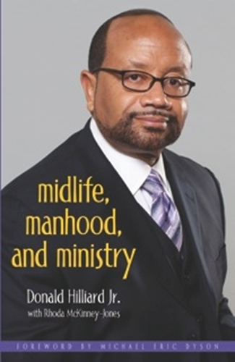
Bishop Donald Hilliard Provides Men with a Guiding Light
through the Murky Waters of Midlife
MIDLIFE, MANHOOD, & MINISTRY
Donald Hilliard Jr.
with Rhoda McKinney-Jones

“Bishop Donald Hilliard has dared to tell the truth, and if you take what he has written seriously, it may save your life.”
—The Rev. Dr. Michael Eric Dyson, Professor of Sociology, Georgetown University
Marriage…Emotional…Wellness…Health…Temptation…Infidelity…Addictions…Self-esteem…Church Politics
With great heart and compassion, Bishop Donald Hilliard has revealed the hidden issues men in ministry face as they approach midlife. For too many clergy, the need to develop spiritual and professional relationships that foster personal growth has taken a back seat to their call to the cloth. Through open and candid interviews with faith leaders across the country, Hilliard uncovers how these men of God often suffer in silence even as they continue to nurture the souls of their flock, friends, and family.
The author courageously weaves his own challenging journey into midlife throughout these powerful stories that reflect emotion and vulnerability rarely seen from behind the pulpit. The result is extraordinary lessons of transformation in the midst of transition. Midlife, Manhood & Ministry begins a process of healing and hope that guides men to develop solutions to better manage their lives and their ministries with faith, grace and character. Included is a chapter that explores biblical men who strove to master their own midlife crises.
“For those of us in Christian ministry, the too-often self-imposed and congregational need for us to project an impenetrable strength and “superhero” emotional stamina mitigates against our human need for counsel, stress relief and therapy. Bishop Hilliard creates a safe and spiritually therapeutic path for us to begin our healing.”
— Bishop John R. Bryant, Senior Bishop and Presiding Prelate, Fourth Episcopal District of the African Methodist Episcopal Church
DONALD HILLIARD JR., D. Min., is a Son, Husband, Father, Pastor, Painter and Professor. A true Renaissance Man who celebrates this year thirty years as Senior Pastor of Cathedral International, one church in three locations. Bishop Hilliard serves as President of the Pastor’s Leadership Alliance Network, and travels the world as a renowned preacher, who is also a motivational speaker. In 2006, Bishop Hilliard resurrected his gift of painting by creating original art, Pulpit to the Palette Art, which includes premier collections of over 70 original works. He holds degrees from Eastern College (now Eastern University), Princeton Theological Seminary (as a Samuel D. Proctor Fellow), and United Theological Seminary. Bishop Hilliard is the author of twelve books including Church Growth from an African American Perspective (Judson Press: 2006) and After the Fall (Destiny Publishing: 2007). Bishop Hilliard’s vitally necessary and relevant book, Stop the Funeral, will debut as a stage play in April 2013 in Rahway, NJ.
April 2013 Release ■ $15.99 ■ ISBN: 9780817017293 ■ Publisher: JUDSON PRESS ■ Paperback
To order, call 1-800-458-3766, or visit www.judsonpress.com

