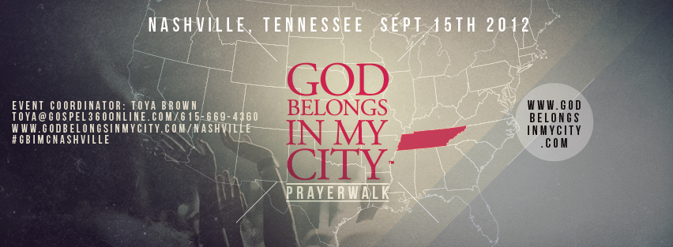
July 27, 2012

Dear Brother and/or Sister In Christ:
My name is Toya Brown, Executive Director of Gospel360Online.com and the Event Coordinator for God Belongs In My City- Nashville. I would like to cordially invite you and your congregation to join me on September 1st and 15th 2012 for the God Belongs In My City-Nashville Prayer Rally and Prayer Walk.
God Belongs In My City (www.GodBelongsInMyCity.com) is a public declaration of our faith. There is a call to fearlessly rise up as one and not collapse under the waves of this world- Drugs, Robberies and Burglaries, Gangs, Murders, etc.!! These contaminants are consuming our communities and it is time to take back our streets and let the world know that GOD IS HERE AND BELONGS IN OUR CITY! Will you join me?
On Saturday, September 1st from 1 pm- 4 pm at McFerrin Park located at 310 Grace Street, Nashville TN 37207, we will be having a Prayer Rally to encourage the community to come out and join us for the Prayer Walk. This event is free and open to the public. We are in need of Choirs, Praise Teams/Dancers, Soloists, etc. and/or Volunteers to contribute to this event.
On Saturday, September 15th from 10 pm-2 pm, also at McFerrin Park, we will march around the park in our God Belongs In My City T-Shirts declaring not only God Belongs In Our City, but as well as “God Belongs In Our State”. We will conclude the prayer walk with a time of prayer in the middle of the park. This movement is completely open to the public and we want all churches to be a part of this time of prayer. Volunteers will also be needed to distribute water to those participating in the walk.
“If my people, which are called by my name, shall humble themselves, and pray, and seek my face, and turn from their wicked ways; then will I hear from heaven, and will forgive their sin, and will heal their land.”- 2 Chronicles 7:14 KJV
For more information, please feel free to contact me at 615-669-4360, Toya@Gospel360Online.com and/or visit our website at www.GodBelongsInMyCity.com/Nashville to register.
Thank you so much for your support and God Bless!
Yours In Christ,
Toya Brown
Executive Director/Event Coordinator
Gospel360Online.com/God Belongs In My City- Nashville

